🏥 HOSPITAL DATA SQL ANALYSIS

Project Title: Hospital Data Analysis Using SQL
Tool Used: MySQL
Database: hospital_info
Table: hospital_data

-- Q1.Write an SQL query to find the total number of patients across all hospitals.
SELECT SUM(`Patients Count`) AS total_patients
FROM hospital_data;
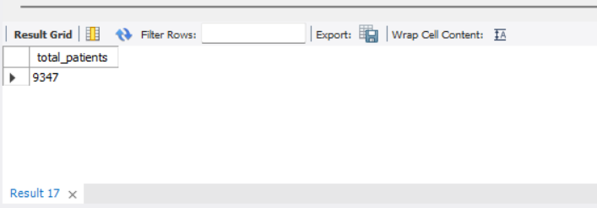

--Q2. Retrieve the average count of doctors available in each hospital.
SELECT AVG(`Doctors Count`) AS average_doctors
FROM hospital_data;
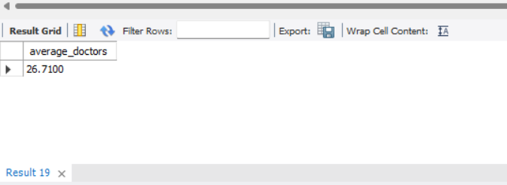

--Q3. Find the top 3 hospital departments that have the highest number of patients.
SELECT `Department`,
SUM(`Patients Count`) AS total_patients
FROM hospital_data
GROUP BY `Department`
ORDER BY total_patients DESC
LIMIT 3;
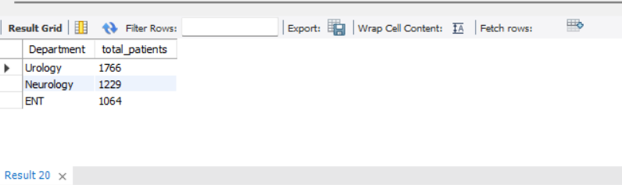

--Q4. Identify the hospital that recorded the highest medical expenses.

SELECT `ï»¿Hospital Name`,
`Medical Expenses`
FROM hospital_data
ORDER BY `Medical Expenses` DESC
LIMIT 1;
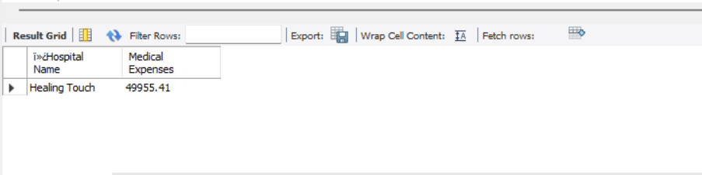

--Q5. Calculate the average medical expenses per day for each hospital.
SELECT `Admission Date`, `Discharge Date`
FROM hospital_data
LIMIT 5;SELECT `ï»¿Hospital Name`,
AVG(
`Medical Expenses` /
DATEDIFF(
STR_TO_DATE(`Discharge Date`, '%d-%m-%Y'),
STR_TO_DATE(`Admission Date`, '%d-%m-%Y')
)
) AS avg_expenses_per_day
FROM hospital_data
GROUP BY `ï»¿Hospital Name`;
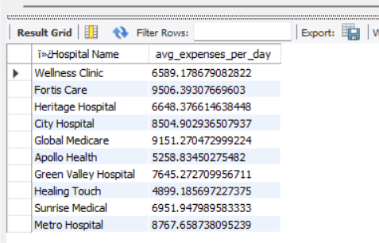

--Q6. Find the patient with the longest stay by calculating the difference between Discharge Date and Admission Date.
SELECT `ï»¿Hospital Name`,
`Admission Date`,
`Discharge Date`,
DATEDIFF(
STR_TO_DATE(`Discharge Date`, '%d-%m-%Y'),
STR_TO_DATE(`Admission Date`, '%d-%m-%Y')
) AS length_of_stay
FROM hospital_data
ORDER BY length_of_stay DESC
LIMIT 1;


--Q7.Count the total number of patients treated in each city.
SELECT `Location`,
SUM(`Patients Count`) AS total_patients
FROM hospital_data
GROUP BY `Location`;
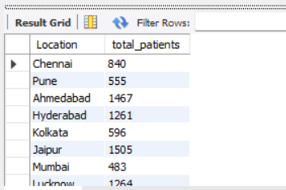

--Q8. Calculate the average number of days patients spend in each department.
SELECT `Department`,
AVG(
DATEDIFF(
STR_TO_DATE(`Discharge Date`, '%d-%m-%Y'),
STR_TO_DATE(`Admission Date`, '%d-%m-%Y')
)
) AS average_days
FROM hospital_data
GROUP BY `Department`;
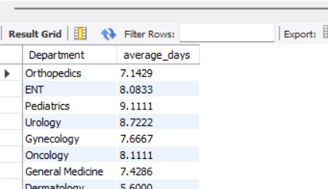

--Q9. Find the department with the least number of patients.
SELECT `Department`,
SUM(`Patients Count`) AS total_patients
FROM hospital_data
GROUP BY `Department`
ORDER BY total_patients ASC
LIMIT 1;
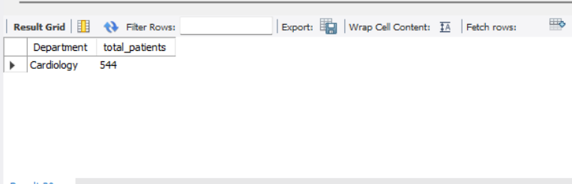

-- Group the data by month and calculate the total medical expenses for each month.
SELECT DATE_FORMAT(
STR_TO_DATE(`Admission Date`, '%d-%m-%Y'),
'%Y-%m'
) AS month,
SUM(`Medical Expenses`) AS total_expenses
FROM hospital_data
GROUP BY month
ORDER BY month;
